Online Sales Information Web Portal
Software Requirements Specification

Version 1.0



Group Id: F1602D8399
Supervisor Name: Faizan Tahir

Revision History
Date (dd/mm/yyyy) | Version | Description | Author
05/12/2016 | 1.0 | SRS document includes  1:- Scope of the project  2:- Functional and Non-Functional Requirements  3:- Use Case Diagram  4:- Usage Scenarios  5:- Adopted Methodology  6:- Work Plan | Bc120400918

Table of Contents

- Scope (of the project)
- Functional Requirements Non Functional requirements
- Use Case Diagram
- Usage Scenarios
- Adopted Methodology
- Work Plan (Use MS Project to create Schedule/Work Plan)

SRS Document

Scope of Project:

A Web portal is most frequently a specially considered web site that brings information together from varied sources. This portal is vastly dynamic and interactive. They offer scope for instant query addressing, subscribing / unsubscribing to notification and getting the latest notifications of all the events and happenings on this portal. This portal is user-friendly to the right audience, easy for that audience to find, and provides information the targeted audience wants and needs. It is not probable to purchase products online on web portal. Online sales information tends to provide more information about items for sale than you would get in a physical store.
To get know about products over the internet without need of going physically to the market is what online sales information all about. Online sales information web portal has made more fun. It shows offer product description, pictures, comparisons, price, and much more. Wastage of time didn’t take place. Your searching becomes easy. Online sales Information web portal allows a registered customer to get notification about a variety of products. If a visitor is viewing a web portal that is not registered then he registered to site by registration form. It’s also provides security with the use of login-id and password so that any unauthorized users can not use your account. If a user is registered to the site he can edit subscription, ratings and posted comments. The only authorized that will have proper access authority can access the web portal.

Functional and non Functional Requirements:

Functional Requirements
- Administrative
- Functionality
- Usability
- Login & Registration:-
User should be sign up their account
- Add customer Detailed product categorizations
The system shall display detailed product categorization to the user.
- Authenticate Users
- View details
- Provide edit subscription, ratings & posted comments

Non-Functional Requirements
Non-functional requirements are not concerned with the functions of the system. They look at the criteria to which the software or website is predictable to be convertible to no-functional requirements.
- Performance requirements
- Quality requirements
- Reliability:-
The system will consistently perform its intended function.
- Reusability
- The interface of online sales information web portal.
- The design ad styling of online sales information web portal.
- The web portal shall be available via browser.
- Security requirements

- Maintainability:- Application would be user friendly.
- Application would be user friendly.

Use Case Diagram(s):

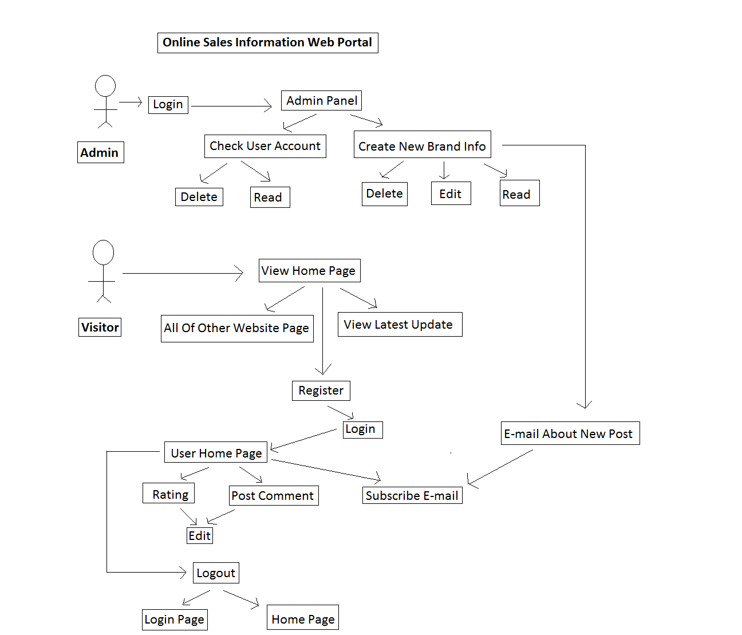

Usage Scenarios:

Use Case Title | Admin
Use Case Id | 1
Description: This use case is about authority of admin.
Pre Conditions:
- All must require information about visitors.
Task Sequence |  | Exceptions
- Admin can create new information about brands.
- After can check user’s account.
- Admin can delete or read or edit brands information.
Post Conditions:
- Admin authority succeeds.
Unresolved issues:
Authority: Administrator
Modification history: 1.0
Author: < Bc12040400918 >
Description:

Use Case Title | Register
Use Case Id | 2
Description: This use case is about register a new user to the system to use the online sales information web portal.
Pre Conditions:
  - All must require information about the new user should be available.
Task Sequence |  | Exceptions
- Administrator adds a new user account.
- Administrator asks for necessary information.
- Administrator provides all the required information and options to complete the operation.
- Administrator after confirmation adds the new account.
Post Conditions:
  - A new user account is successfully created.
Unresolved issues:
Authority: Administrator
Modification history: 1.0
Author: < Bc120400918 >
Description:

Use Case Title | Visitor
Use Case Id | 3
Description: This use case is about visitor browse and to know about latest brands information and subscription.
Pre Conditions:
- All must require latest information about brands should be available.
- In this case visitor must browse and register web portal.
Task Sequence |  | Exceptions
- Visitor browses the web portal.
- Visitor can subscribe.
- Visitor can edit rating and post comment.
- Visitor should get e-mail about latest info brands.
Post Conditions:
  - Visitor requirements fulfill
Unresolved issues:
Authority: Visitor
Modification history: 1.0
Author: < Bc120400918>
Description:

Adopted Methodology

The adopted methodology for this project is vu process model. Vu process model is a permutation of water-fall model and spiral model. This combination has many advantages. This model has elevated risk psychotherapy so evasion of risk would be achieved. This model is simple to understand and use. Now first we will discuss the Water-fall model:

Waterfall Model:

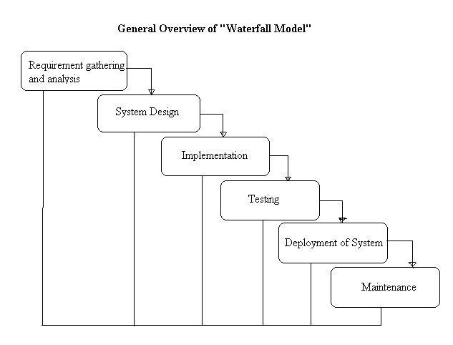

The waterfall model is a sequential design procedure, used in software development processes, in which progress is seen as flowing gradually downwards through the phases of commencement, instigation, analysis, design, creation, testing, production/implementation and maintenance.
The waterfall development model initiates in the manufacturing and construction industries: extremely structured physical situations in which after the fact changes are prohibitively pricey, if not impossible. Because no prescribed software maturity methodologies survived at the time, this hardware oriented model was simply modified for software development.
Waterfall model have different stages which is starting from requirements phase and ends at reception phase.

Requirement Gathering and Analysis:

All possible requirements of the system to be residential are captured in this segment and renowned in a requirement specification document.
System Design:
The requirement specifications from first stage are studied in this phase and system design is equipped. System Design helps in specifying hardware and system supplies and also helps in imperative overall organism architecture.
Implementation:
With inputs from classification propose, the system is first developed in small programs called units, which are built-in in the next phase. Each unit is developed and weathered for its functionality which is referred to as unit testing.
Testing:
All the units developed in the implementation phase are included into a system after testing of all units. Post incorporation the whole system is experienced for any errors.
Deployment of System:
Once the functional and non functional testing is done, the product is organized in the customer environment or free into the market.
Maintenance:
There are some matters which come up in the consumer situation. To attach those issues patches are released. Also to improve the produce some better versions are released. Maintenance is completed to deliver these changes in the customer environment.
Now we will discuss the spiral Model and VU Model.
Spiral Model:

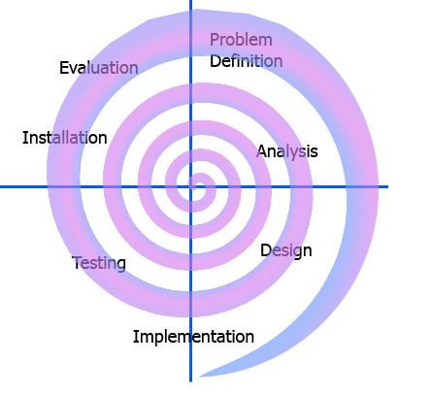

The spiral model is a risk-driven process model producer for software projects. Based on the exclusive risk patterns of a given project, the spiral model guides a team to assume elements of one or more course models, such as incremental, waterfall.
The spiral model has four phases. A software project frequently passes through these chapters in iterations called Spirals.

VU Process Model:

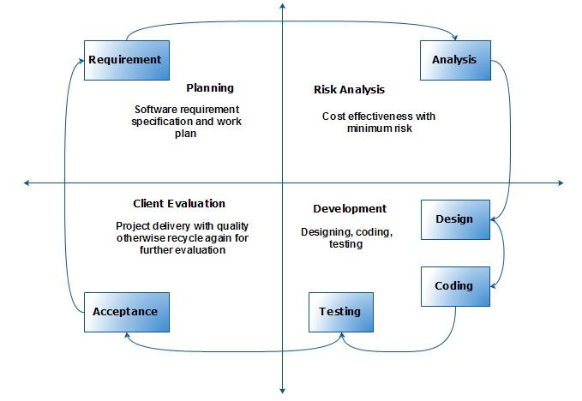

This Process Model combination of watrfall model and Spiral Model. This process model maximizes the superiority of system and reduces the risk and disadvantages.

Work Plan (Use MS Project to create Schedule/Work Plan)

Start Date End Date
SRS 17/11/2016 5/12/2016
Design Phase 07/12/2016 10/01/2017
Test Phase 1 12/01/2017 18/01/2017
Test Phase 2 20/01/2017 30/01/2017
Final Deliverable 31/01/2017 17/04/2017

